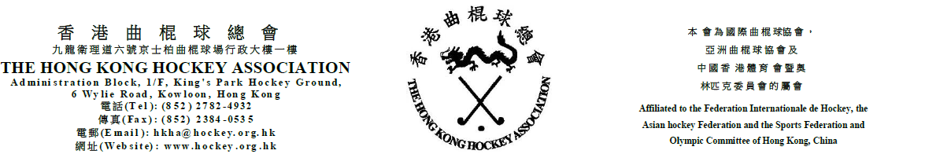
12 June 2020

To: Convenors of Affiliated Clubs (Youth & Mini)
CC: HKHA Council Members
HKHA Sections’ Committee Members

AGENDA
Annual General Meeting 2019-2020 of HKHA P&D

- Adopt the minutes of the AGM 2018 – 2019 (to be tabled)

- Chairman’s Report

- Accounts for the year ended 31st March, 2020

- Election of the officials and committee members

a) for a term of one year
- Committee Members (4 posts)

- Any other business in which due notice has been given.

Yours sincerely,

Simon Chapman
Hon. Secretary
Promotion & Development Section
The Hong Kong Hockey Association

